Chapter 14, Solution 8.

Design a problem to help other students to better calculate the magnitude in dB and phase in degrees of a variety of transfer functions at a single value of ω.

Although there are many ways to solve this problem, this is an example based on the same kind of problem asked in the third edition.

Problem

Determine the magnitude (in dB) and the phase (in degrees) of H(ω) at ω = 1 if H(ω) equals

- 0.05
- 125
- 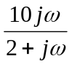
- 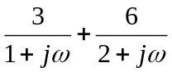

Solution

- 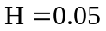
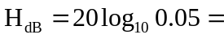, φ = 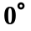

- 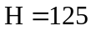
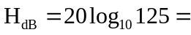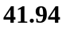, φ =

- 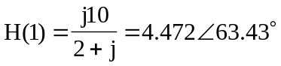
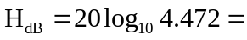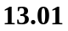, φ = 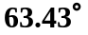

- 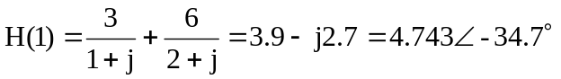
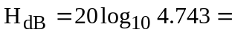 13.521, φ = –34.7˚

